Task 7- Screenshots

Queries -
Design a database:-
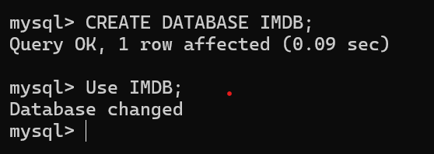

Tables Structure:
Tables Creation:
- Movie table - to store movies details :

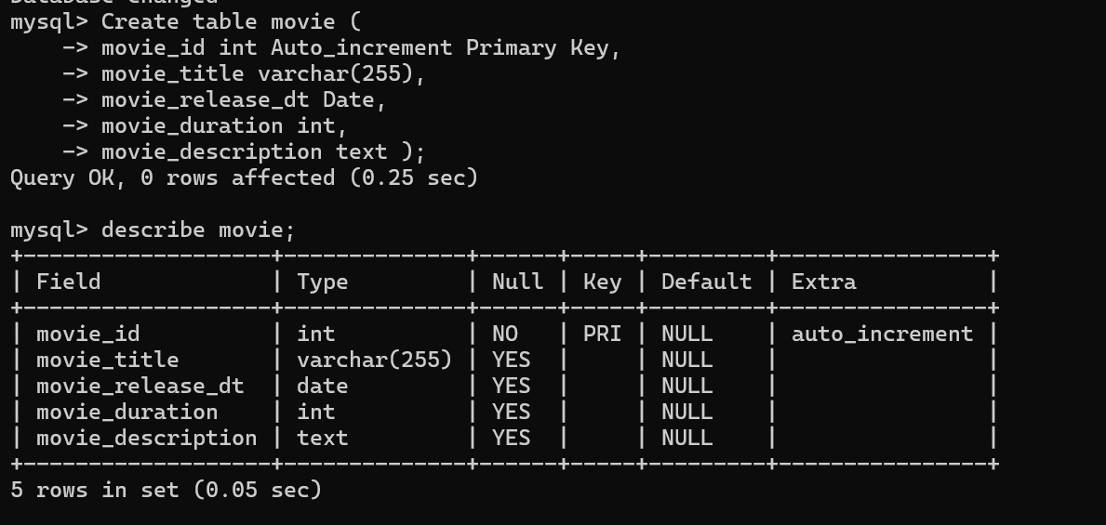

- Media table - to have multiple media details-Video/Image :
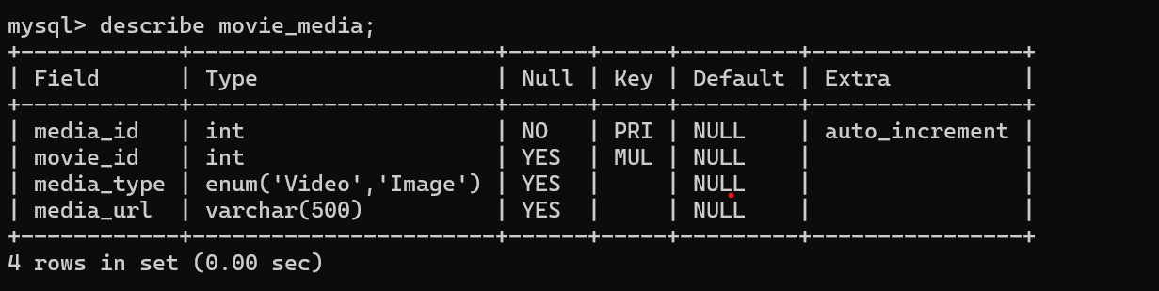

- Genre table - to store movies with different genre :
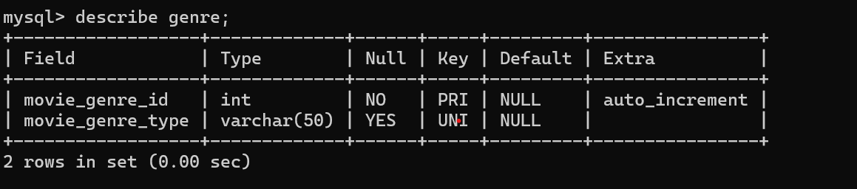

- Movie genre - Many-to-many relationship between movies and genres :
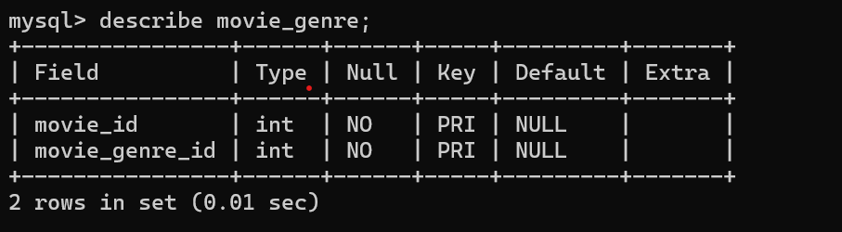

- User table - Users who write reviews :
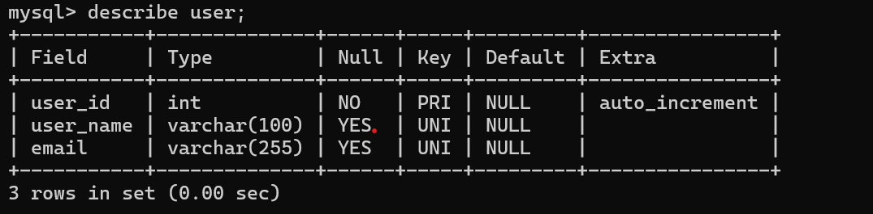

- Review table - to store movie reviews ,
a review belongs to a user and a movie can have multiple reviews:
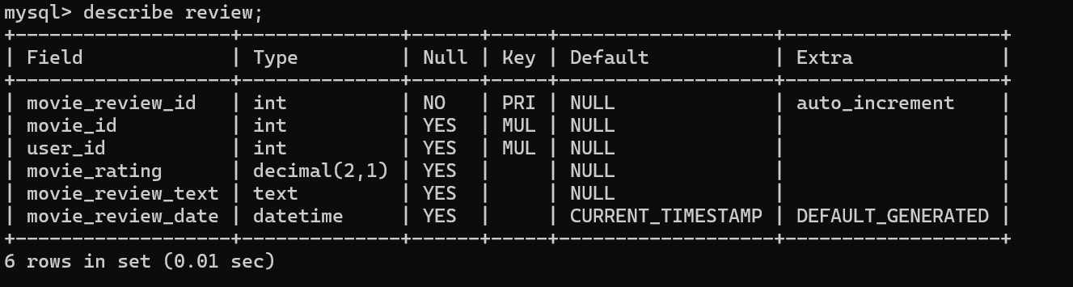

- Artist table - to store artist details (like actors or directors):
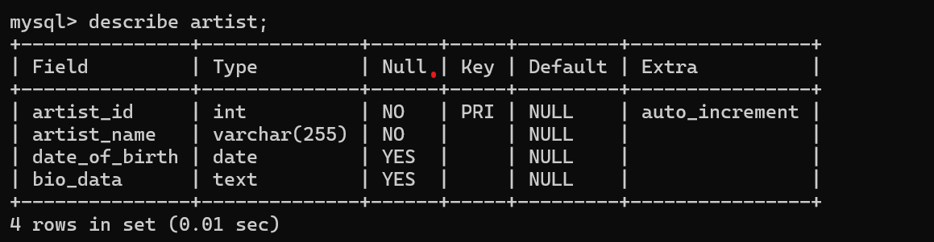

- Skill table - to store skills :

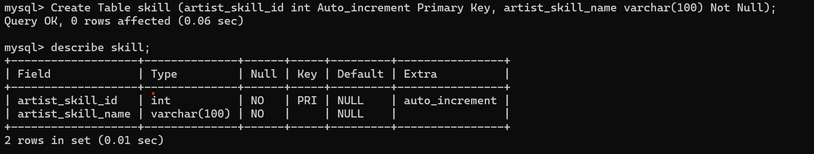
- Artist skill table - to store various skills of Artists like Acting, Direction, Singing, etc :
Many-to-many relationship between artist and skill
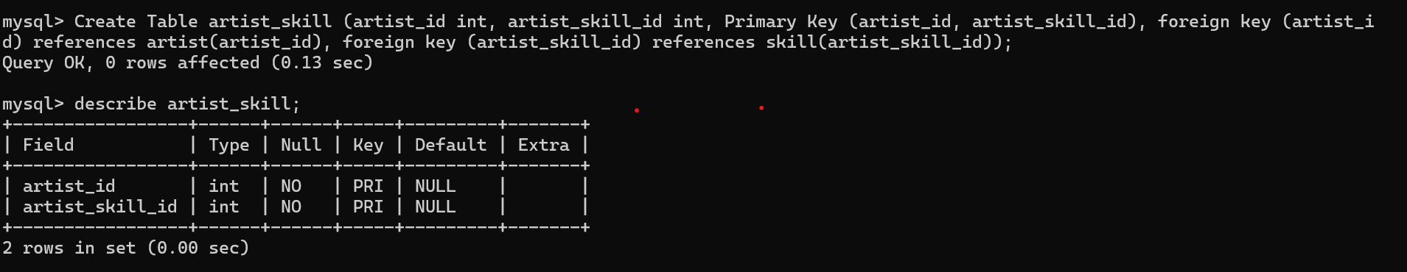

- Artist roles table - to store artist's multiple roles in a single movie like actor, director, singer, etc :
An artist can perform multiple roles in a single movie like actor, director, singer, etc.
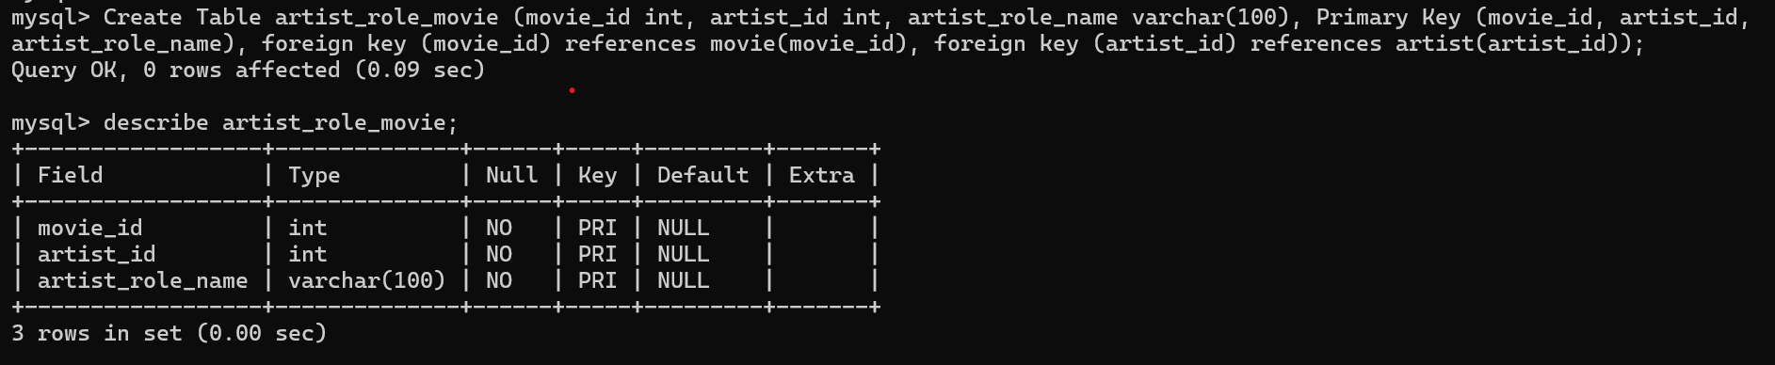

Data Insertion to the Tables :
- Movie table :
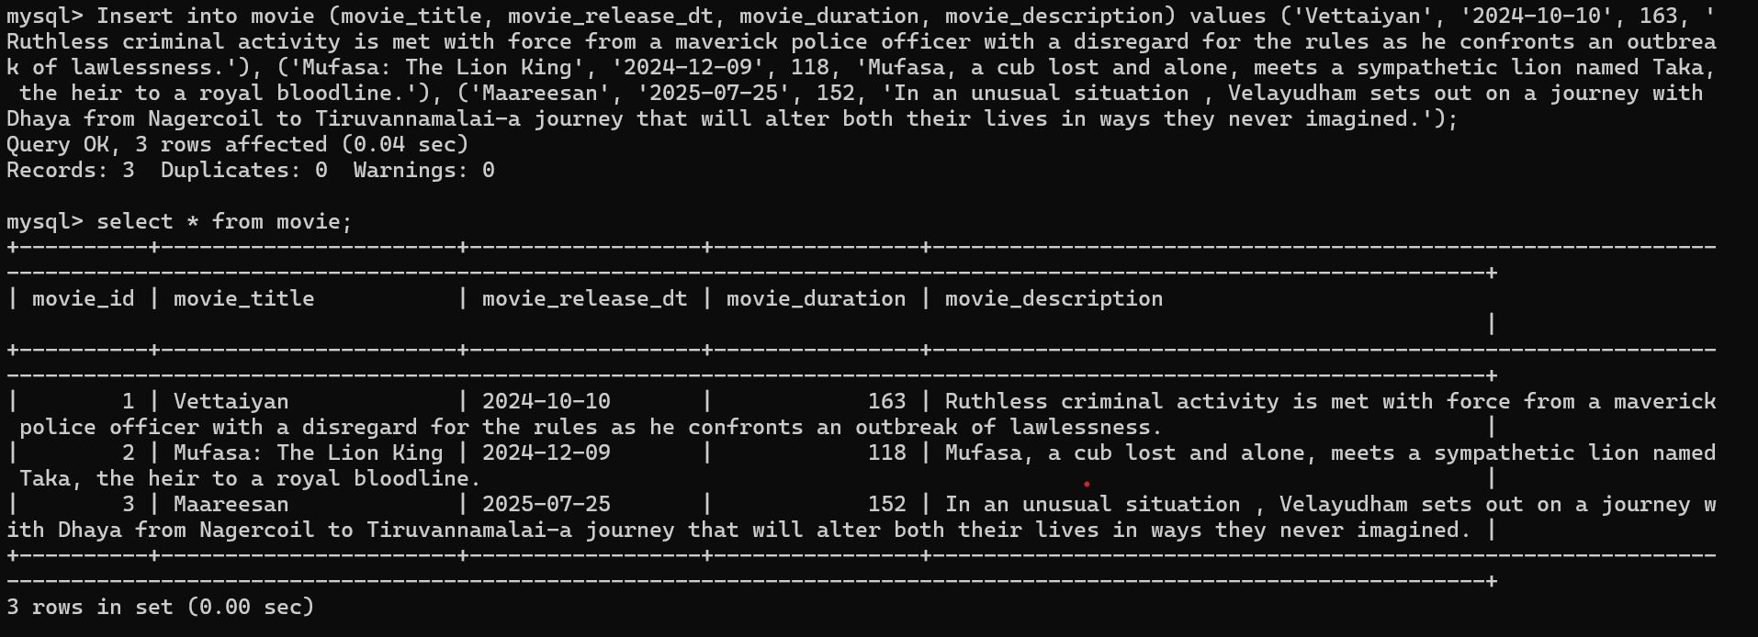

- Media table :
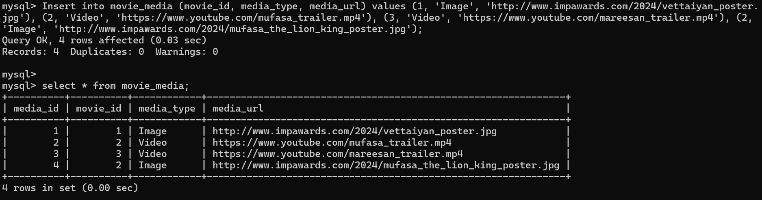

- Genre table :
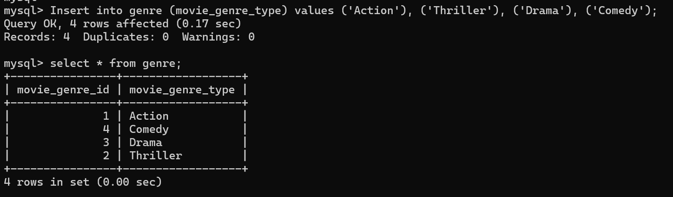

- Movie Genre table :
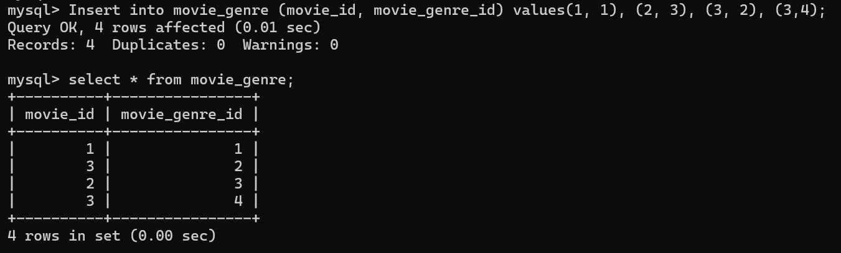

- User table :
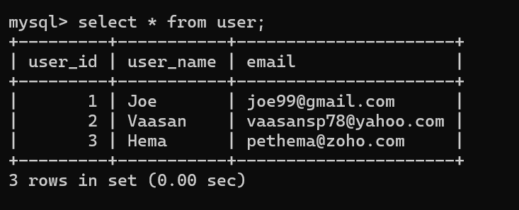

- Review table :
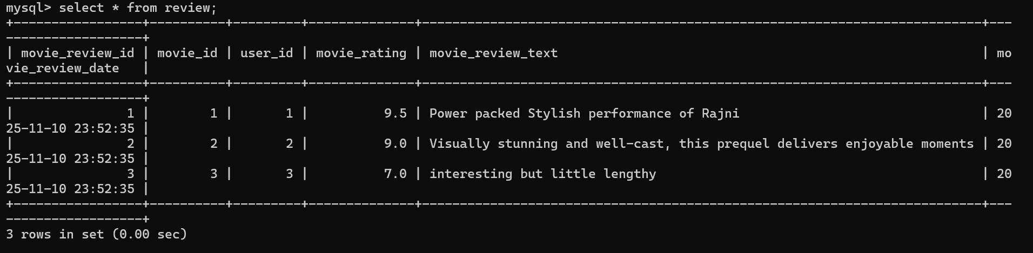

- Artist table :
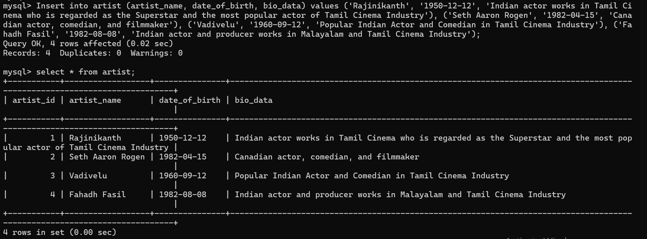

- Skill table :
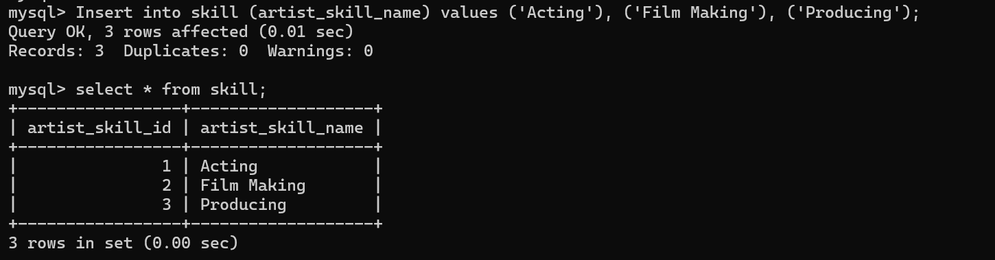

- Artist Skill table :
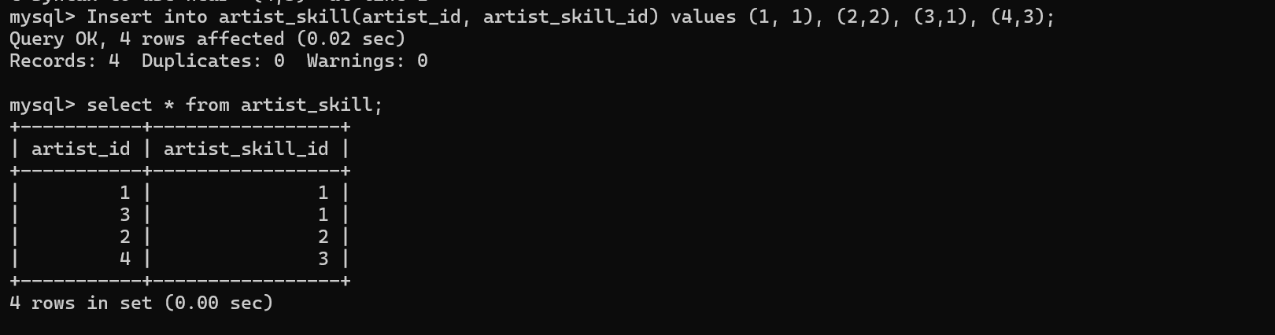

- Artist Role Movie :
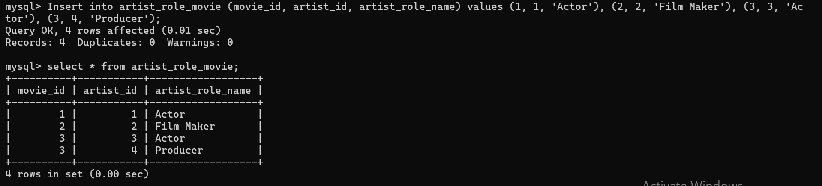
Example scenarios-
Scenario 1:
To list all the movies that follows the same genre:
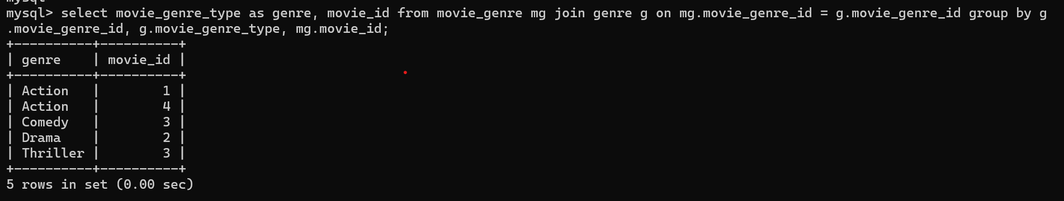

Scenario 2:
To list all the movies acted by particular actor ‘Rajinikanth’:
